Use Case 1：Writing notes.

User open up application.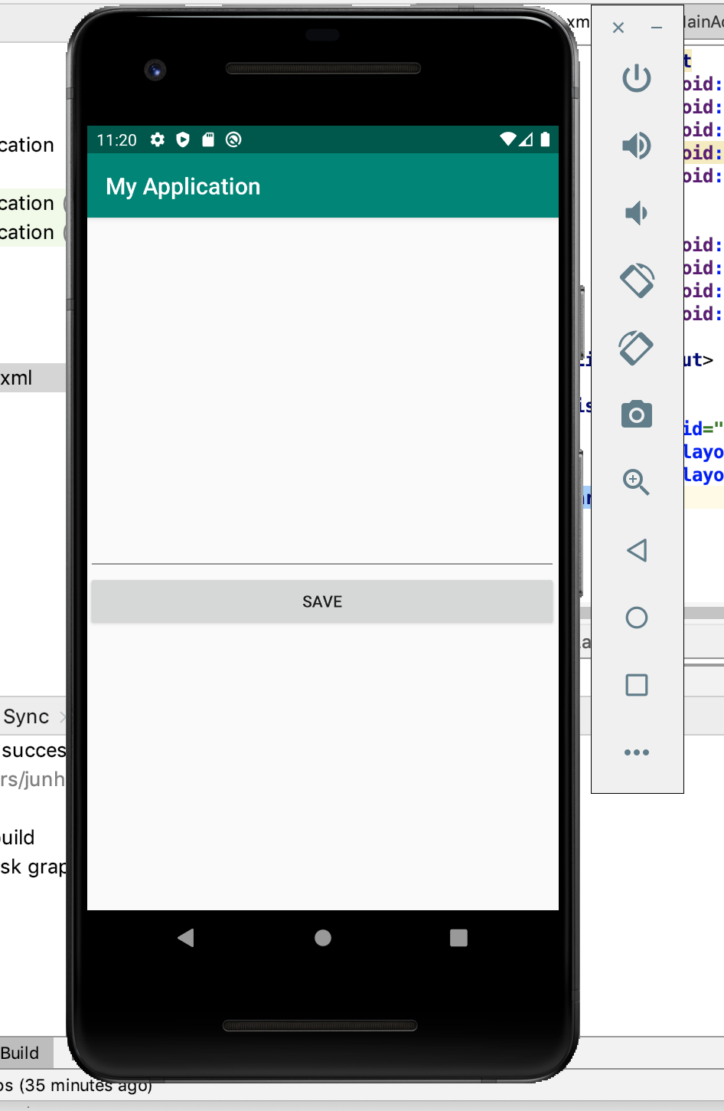

Users type in the notes they need to take.

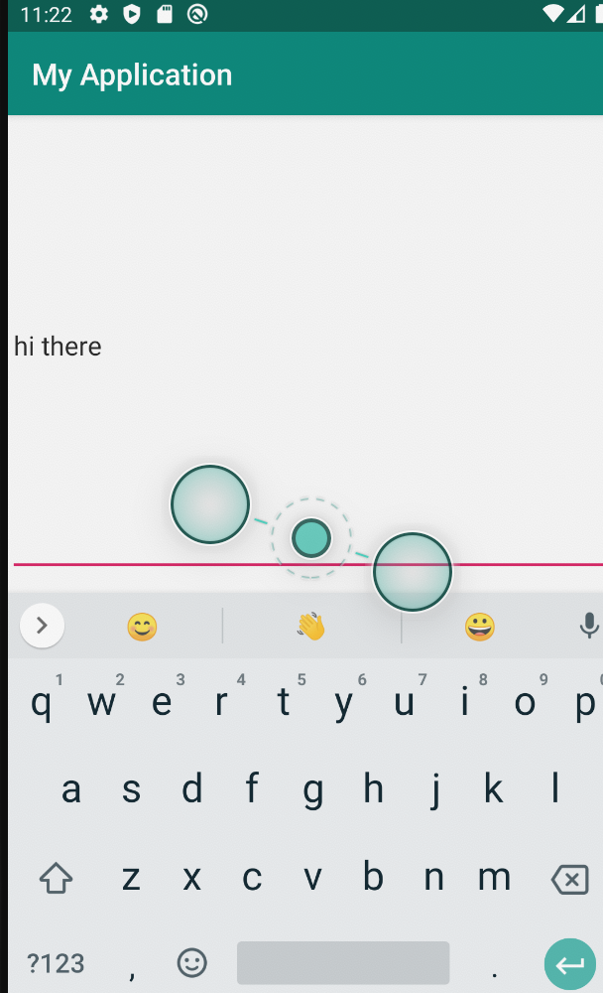

Users click save to save their note.

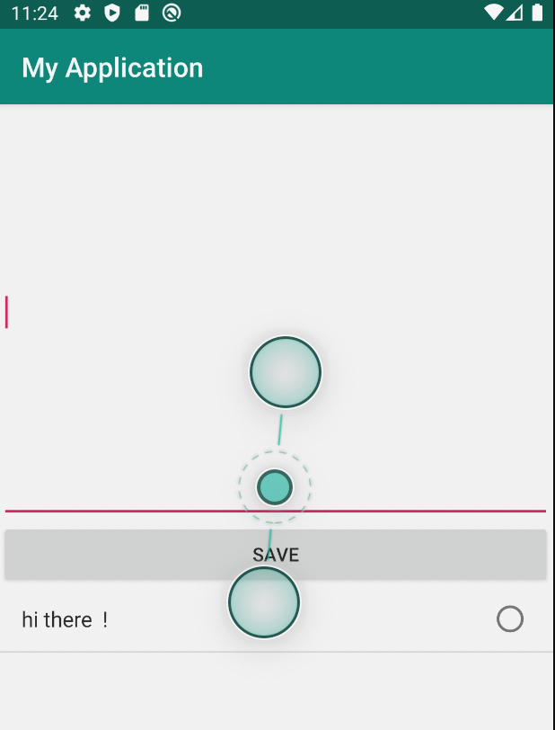

Use Case2: Edit existing notes

Right now notes showing like this.

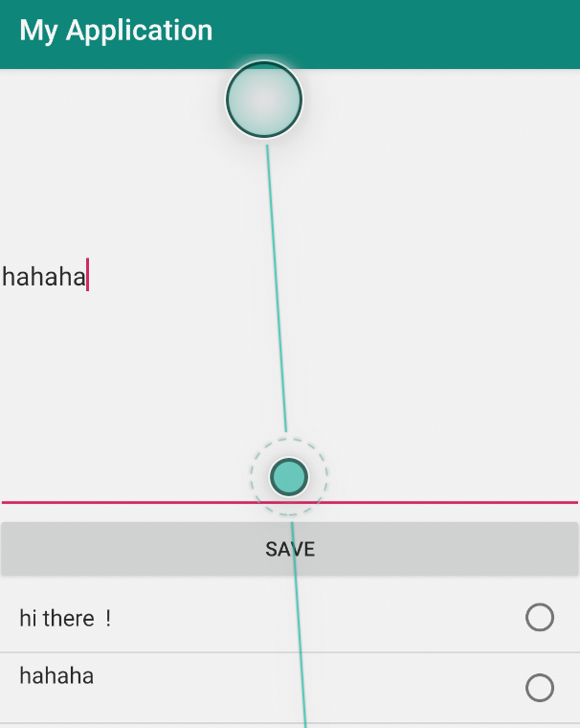

To edit it, user click on the note he or she want to. And then save it.

